Stratification User guide

Purpose
Offer a user interface to calculate and display stratification: aggregate (through average) the horizontal spatial dimension onto the vertical spatial dimension for a time series /image stack. Used with NDVI or relative phonological development (RPD) it can be used to illustrate green wave by overlay of animal tracking data tables.
The user interface has several options to configure both the stratification and the display.
- Stratification:
  - Single year or multi-year (through a list file) time series.
  - Changeable vertical resolution.
- Display:
  - Add multiple track data (different animal, or different time period)
  - Build in color tables or user defined color tables for the stratification

Installation
Copy the nrs_stratify_gui.sav, the _nrs_menu.sav and the NRS_Utils.sav files into the save_add folder of ENVI, and (re)start ENVI. For detailed instructions see also ENVI .sav files: Installation and configuration

Running
Start ENVI. In the NRS menu select NDVI Stratification or type nrs_stratify_gui on the command line:
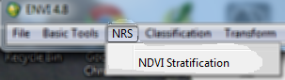
You will see the following interactive user interface:
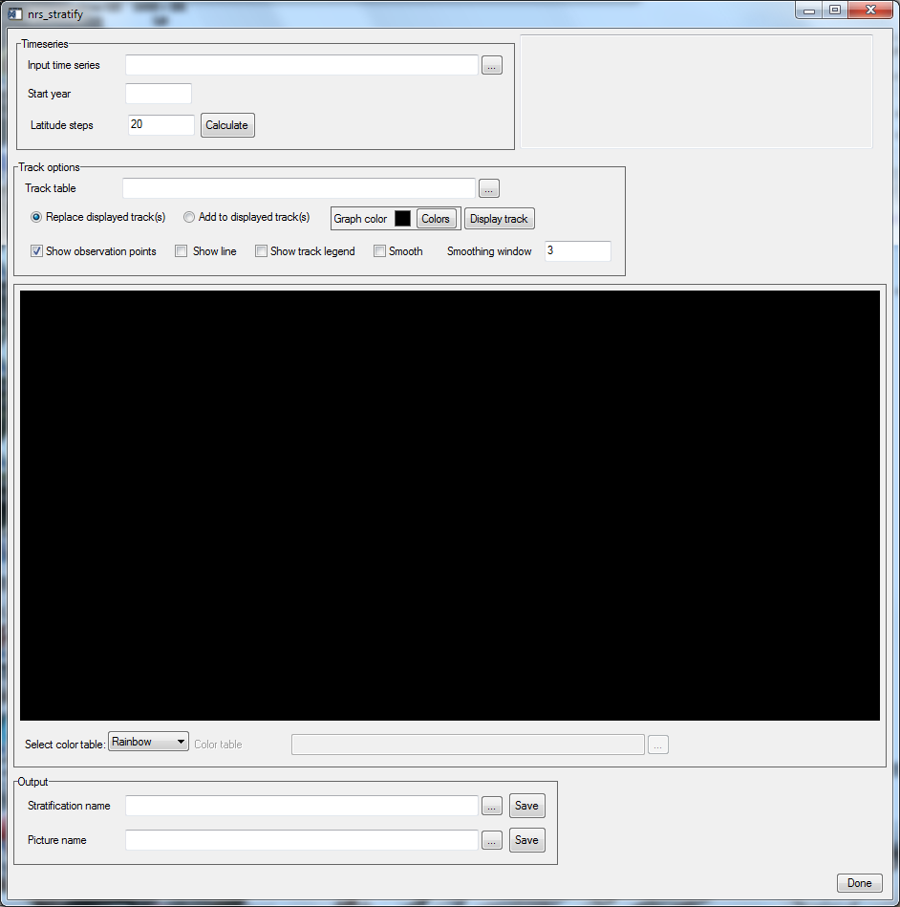
The GUI has several sections:
- Time series
- Track options
- Display area
- Output

Timeseries:
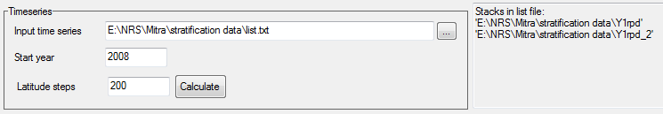
Where:
- Input time series: Either specifies a single time series image stack, or a text file with a list of time series stacks. In case of a list file the panel on the right lists all the image stacks in the list.
- Start year: Each time series stack is assumed to contain one full year of data starting at the first of January. To be able to overlay animal track data the software needs to know the start year.
- Latitude steps: This defines the vertical resolution of the stratification. The latitude extents are split up in as much steps as specified.
Track options:
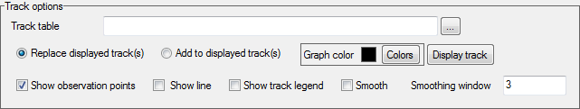
Where:
- Track table: Select a table from disk. This table contains the location observations ordered by date. For a small example see the section Track table format below.
- Replace displayed track(s): when this option is selected the Display Track button will replace any displayed track on the stratification.
- Add to displayed track(s): when this option is selected the Display Track button will add the new track observations to the existing ones on the stratification.
- Graph color: select the color for the graph to be displayed (selected in track table). If other graphs are already being displayed they will retain their colors
- Display track: display the track table by adding / replacing (see options 2 and 3)
- Show observation points: when this option is selected display the observations in the track data as points. Each track will get its own node style.
(Note: when the smooth option is selected the observation points are still the actual data points)
- Show line: when this option is selected a line is drawn. The line will be drawn in between the observation points if the smooth option is not selected.
- Show track legend: when selected a legend is displayed on top of the stratification.
- Smooth: when this option is selected the line between observations points will be smoothed with a moving window smoothing filter (linear interpolation)
- Smoothing window: The size of the moving window for the interpolation. The window size is determined by the temporal axis. So a 16-day product requires a smaller window size (approx. 3 to 5) and a daily product needs a bigger window (f.e. 20 to 30). The exact window size can be determined by experimenting.

Display area:
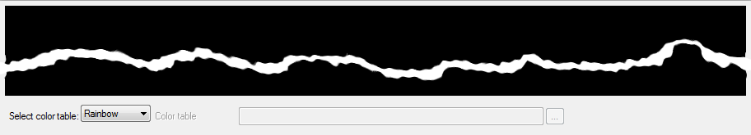
Where:
- Display area: this is the area where the stratification ends up being displayed.
- Select color table: Select the from predefined color tables Rainbow or Black/White, or select Custom for a user defined color table. The custom table can be in two formats, see the section Color table format below for examples.
- Color table: This selection box is available for the Custom selection only. It allows the user to select any comma separated text file (.CSV) with the color table.

Output
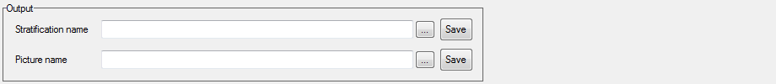
Where:
- Stratification name: (optional) the name of the file to store the stratification matrix to (in ENVI format).
- Picture name: (optional) the name of the JPG file to write the contents of the draw window.

The files can be written at any time after the stratification is completed and don’t need to be specified until then.

Track table format
The track table is a text file with comma delimited content. It must contain 3 columns of data with one header line.
Columns:
- The first column contains the year as YYYY.
- The second columns contains the day of the year as a number between 1 and 366.
- The third column contains the values to be used in the graph as floating point numbers. The name for the legend is taken from the header line.
Below is an example of such a table.
Year,Doy,Greenland
2008,96,54.1277875
2008,112,54.1277875
2008,113,63.819975
2008,119,65.49151
2008,148,73.06033
2008,253,73.0105
2008,268,64.08866667
2008,278,55.791165
2008,291,54.11075

Color table format
The color table format can be one of two formats. Both are comma separated text files, with one header line.
Type 1 contains three columns that are interpreted as red, green and blue. It must have 256 color records. Each record has one color tuple that will be used directly by the software.
Type 2 contains four columns interpreted as limit, red, green and blue. The records are assumed to be ordered according the values in the first column. These limits ranging from 0 to 1 correspond to the minimum and maximum values in the input image. Each limit is a color break. The limits are mapped to the color table range (0 to 255). The colors between two limits are calculated automatically starting from the color break at the lower limit to the color break at the higher limit using linear interpolation.
Type 1 example (256 colors from top to bottom, then from left to right):

r,g,b
0,0,0
4,0,3
9,0,7
13,0,10
18,0,14
22,0,19
27,0,23
31,0,28
36,0,32
40,0,38
45,0,43
50,0,48
54,0,53
58,0,59
61,0,63
64,0,68
68,0,72
69,0,77
72,0,81
74,0,86
77,0,91
79,0,95
80,0,100
82,0,104
83,0,109
85,0,113
84,0,118
86,0,122
87,0,127
88,0,132
86,0,136
87,0,141
87,0,145
87,0,150
85,0,154
84,0,159
84,0,163
84,0,168
83,0,173
79,0,177
78,0,182
77,0,186
76,0,191
71,0,195
70,0,200
68,0,204
66,0,209
60,0,214
58,0,218
55,0,223
53,0,227
46,0,232
43,0,236
40,0,241
36,0,245
33,0,250
25,0,255
21,0,255
16,0,255
12,0,255
4,0,255
0,0,255
0,4,255
0,8,255
0,16,255
0,21,255
0,25,255
0,29,255
0,38,255
0,42,255
0,46,255
0,51,255
0,55,255
0,63,255
0,67,255
0,72,255
0,76,255
0,84,255
0,89,255
0,93,255
0,97,255
0,106,255
0,110,255
0,114,255
0,119,255
0,127,255
0,131,255
0,135,255
0,140,255
0,144,255
0,152,255
0,157,255
0,161,255
0,165,255
0,174,255
0,178,255
0,182,255
0,187,255
0,195,255
0,199,255
0,203,255
0,208,255
0,216,255
0,220,255
0,225,255
0,229,255
0,233,255
0,242,255
0,246,255
0,250,255
0,255,255
0,255,246
0,255,242
0,255,238
0,255,233
0,255,225
0,255,220
0,255,216
0,255,212
0,255,203
0,255,199
0,255,195
0,255,191
0,255,187
0,255,178
0,255,174
0,255,170
0,255,165
0,255,157
0,255,152
0,255,148
0,255,144
0,255,135
0,255,131
0,255,127
0,255,123
0,255,114
0,255,110
0,255,106
0,255,102
0,255,97
0,255,89
0,255,84
0,255,80
0,255,76
0,255,67
0,255,63
0,255,59
0,255,55
0,255,46
0,255,42
0,255,38
0,255,34
0,255,25
0,255,21
0,255,16
0,255,12
0,255,8
0,255,0
4,255,0
8,255,0
12,255,0
21,255,0
25,255,0
29,255,0
33,255,0
42,255,0
46,255,0
51,255,0
55,255,0
63,255,0
67,255,0
72,255,0
76,255,0
80,255,0
89,255,0
93,255,0
97,255,0
101,255,0
110,255,0
114,255,0
119,255,0
123,255,0
131,255,0
135,255,0
140,255,0
144,255,0
153,255,0
157,255,0
161,255,0
165,255,0
169,255,0
178,255,0
182,255,0
187,255,0
191,255,0
199,255,0
203,255,0
208,255,0
212,255,0
221,255,0
225,255,0
229,255,0
233,255,0
242,255,0
246,255,0
250,255,0
255,255,0
255,250,0
255,242,0
255,238,0
255,233,0
255,229,0
255,221,0
255,216,0
255,212,0
255,208,0
255,199,0
255,195,0
255,191,0
255,187,0
255,178,0
255,174,0
255,170,0
255,165,0
255,161,0
255,153,0
255,148,0
255,144,0
255,140,0
255,131,0
255,127,0
255,123,0
255,119,0
255,110,0
255,106,0
255,102,0
255,97,0
255,89,0
255,85,0
255,80,0
255,76,0
255,72,0
255,63,0
255,59,0
255,55,0
255,51,0
255,42,0
255,38,0
255,34,0
255,29,0
255,21,0
255,17,0
255,12,0
255,8,0
255,0,0

Type 2 example:
limit,red,green,blue
0,0,0,0
0.1,48,48,100
0.15,24,204,224
0.3,48,128,76
0.6,48,216,56
0.90,255,255,0
0.95,255,0,0
1.0,255,0,0

The software will calculate 256 colors from the above. The way it works:
- Take a pair of consecutive limits (f.e. 0 and 0.1)
- Calculate the range in the color table: from 0 to 256 * 0.1 = 26
- For each of the 27 positions in the color table perform a linear interpolation from color 1 (0,0,0) to color 2 (48,48,224)
- Do this for all consecutive pairs.

